Pseudo-code

ข้อที่ 1

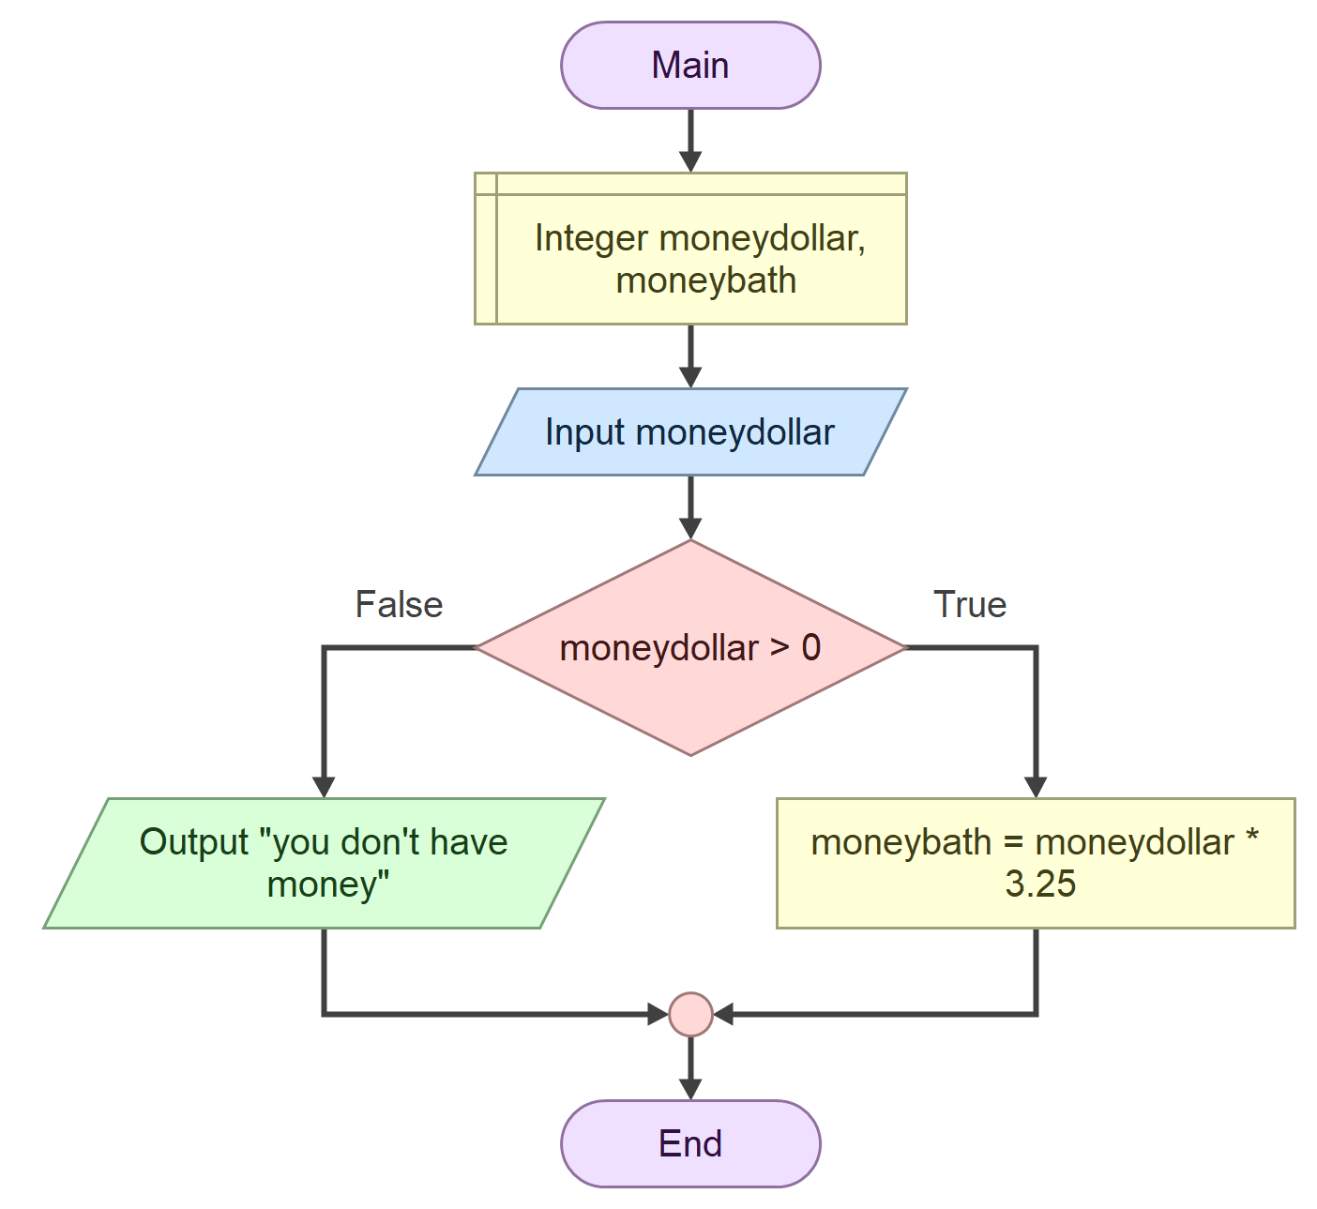

Function Main

Declare Integer moneydollar, moneybath

Input moneydollar

If moneydollar > 0

Assign moneybath = moneydollar * 3.25

Else

Output "you don't have money"

End

End

ข้อที่ 2

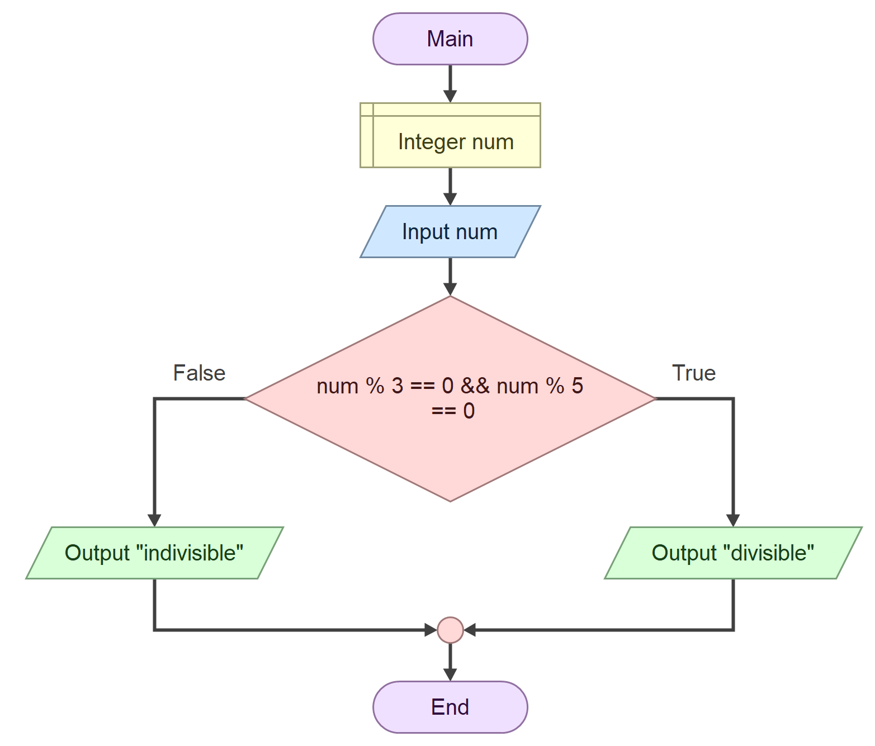

#include <iostream>

#include <sstream>

#include <string>

#include <cstdlib>

#include <cmath>

using namespace std;

// Headers

string toString (double);

int toInt (string);

double toDouble (string);

int main() {

int num;

cin >> num;

if (num % 3 == 0 && num % 5 == 0) {

cout << "divisible" << endl;

} else {

cout << "indivisible" << endl;

}

return 0;

}

// The following implements type conversion functions.

string toString (double value) { //int also

stringstream temp;

temp << value;

return temp.str();

}

int toInt (string text) {

return atoi(text.c_str());

}

double toDouble (string text) {

return atof(text.c_str());

}

ข้อที่ 3

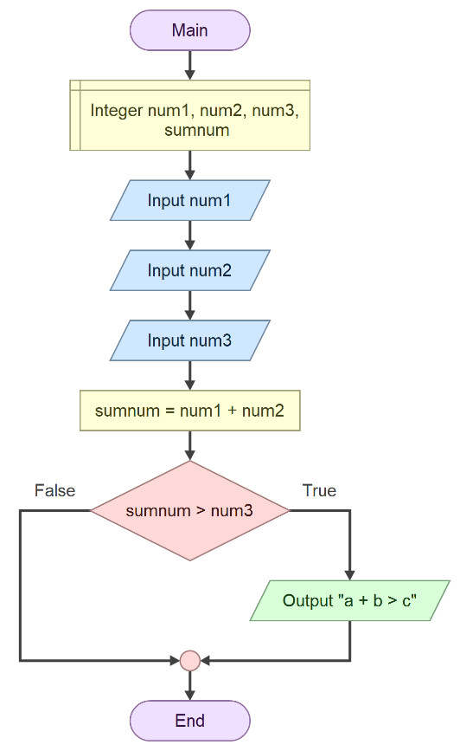

#include <iostream>

#include <sstream>

#include <string>

#include <cstdlib>

#include <cmath>

using namespace std;

// Headers

string toString (double);

int toInt (string);

double toDouble (string);

int main() {

int num1, num2, num3, sumnum;

cin >> num1;

cin >> num2;

cin >> num3;

sumnum = num1 + num2;

if (sumnum > num3) {

cout << "a + b > c" << endl;

}

return 0;

}

ข้อที่ 4

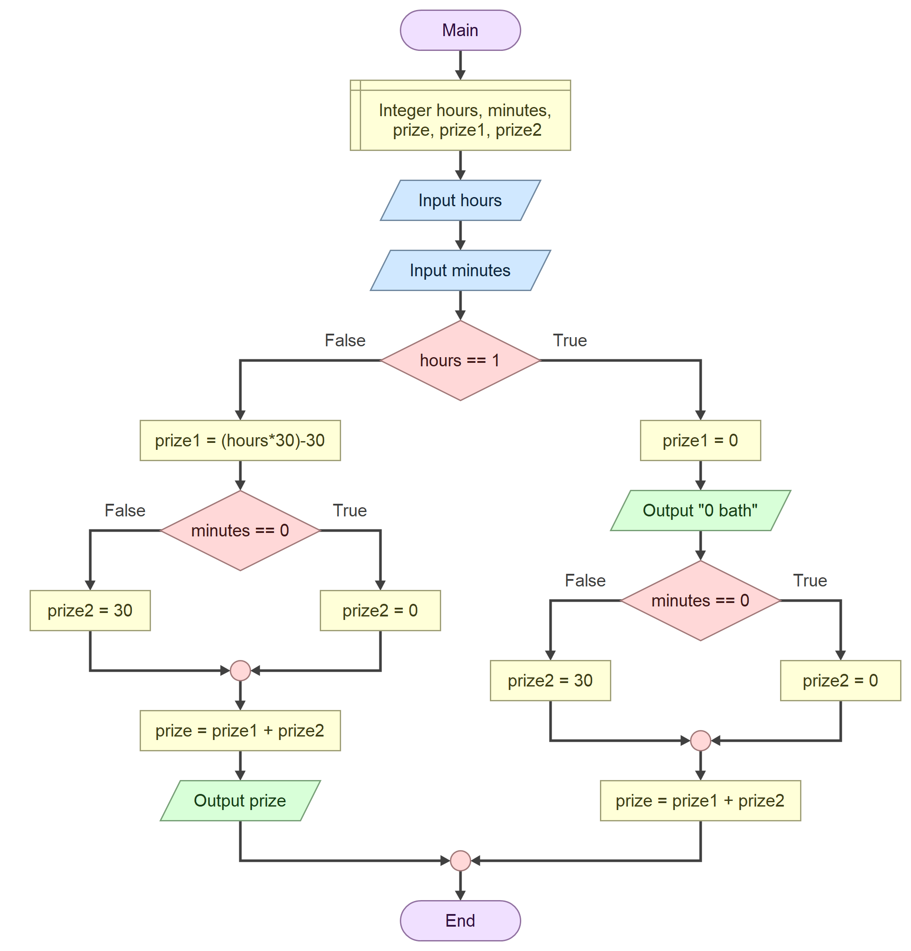

#include <iostream>

#include <sstream>

#include <string>

#include <cstdlib>

#include <cmath>

using namespace std;

// Headers

string toString (double);

int toInt (string);

double toDouble (string);

int main() {

int hours, minutes, prize, prize1, prize2;

cin >> hours;

cin >> minutes;

if (hours == 1) {

prize1 = 0;

cout << "0 bath" << endl;

if (minutes == 0) {

prize2 = 0;

} else {

prize2 = 30;

}

prize = prize1 + prize2;

} else {

prize1 = hours * 30 - 30;

if (minutes == 0) {

prize2 = 0;

} else {

prize2 = 30;

}

prize = prize1 + prize2;

cout << prize << endl;

}

return 0;

}

ข้อที่ 5

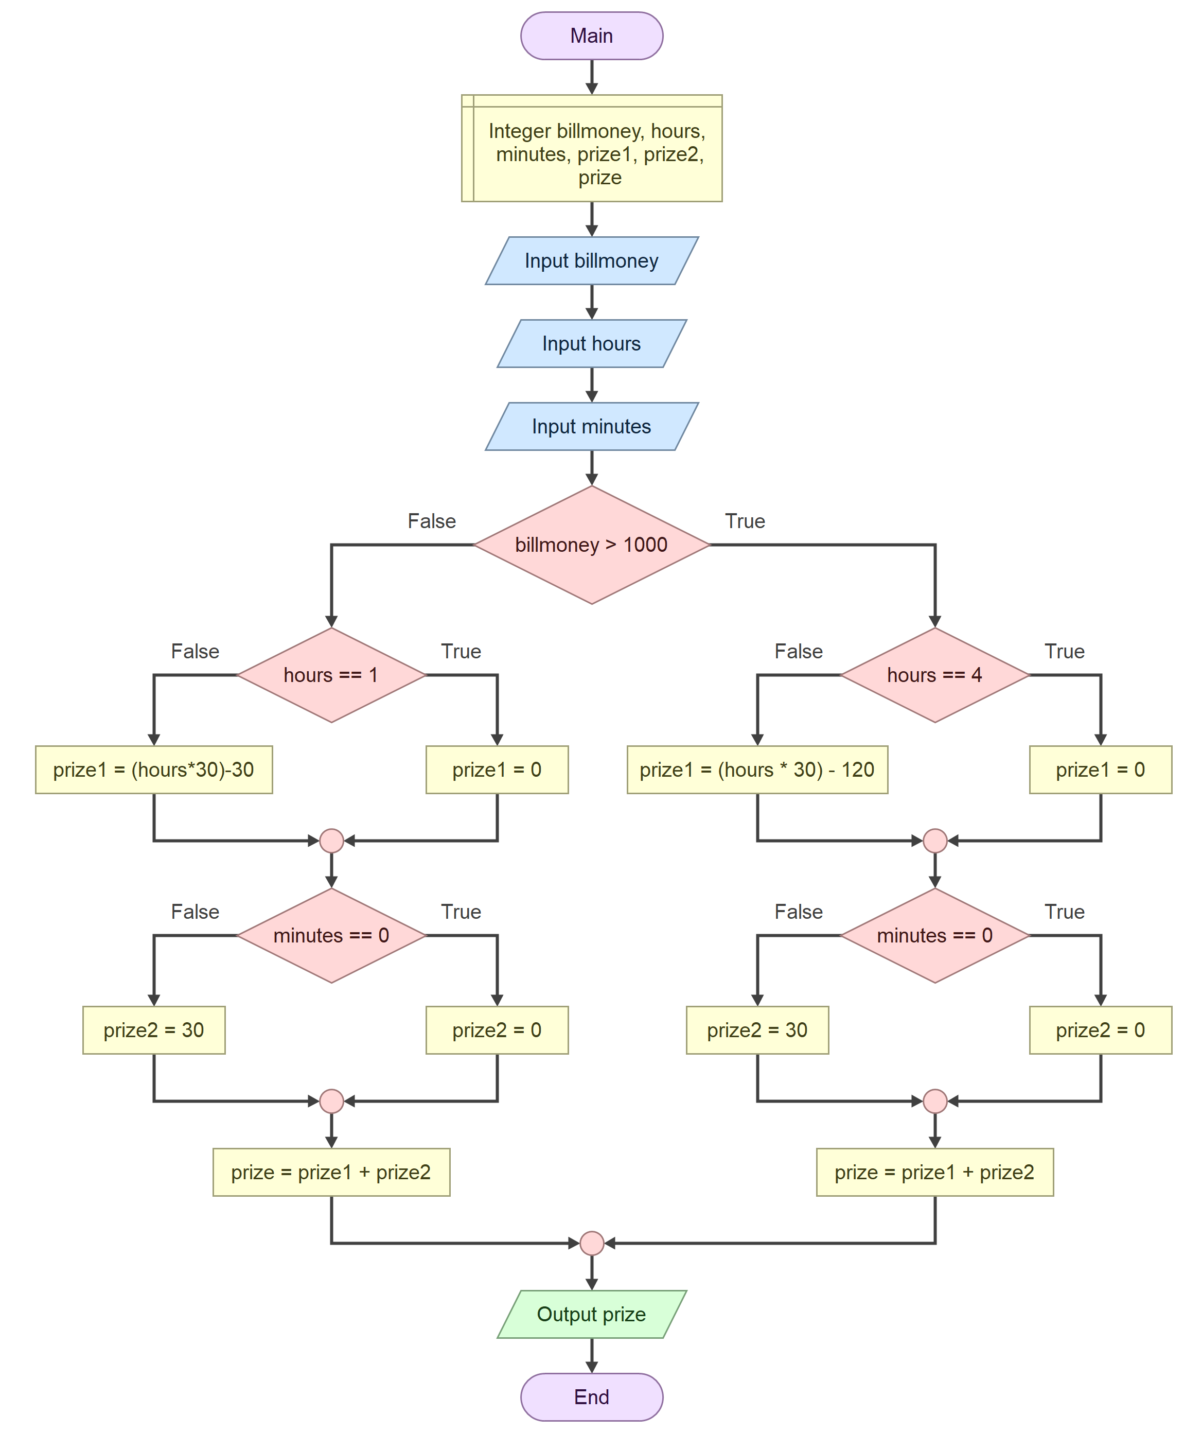

#include <iostream>

#include <sstream>

#include <string>

#include <cstdlib>

#include <cmath>

using namespace std;

// Headers

string toString (double);

int toInt (string);

double toDouble (string);

int main() {

int billmoney, hours, minutes, prize1, prize2, prize;

cin >> billmoney;

cin >> hours;

cin >> minutes;

if (billmoney > 1000) {

if (hours == 4) {

prize1 = 0;

} else {

prize1 = hours * 30 - 120;

}

if (minutes == 0) {

prize2 = 0;

} else {

prize2 = 30;

}

prize = prize1 + prize2;

} else {

if (hours == 1) {

prize1 = 0;

} else {

prize1 = hours * 30 - 30;

}

if (minutes == 0) {

prize2 = 0;

} else {

prize2 = 30;

}

prize = prize1 + prize2;

}

cout << prize << endl;

return 0;

}

ข้อที่ 6

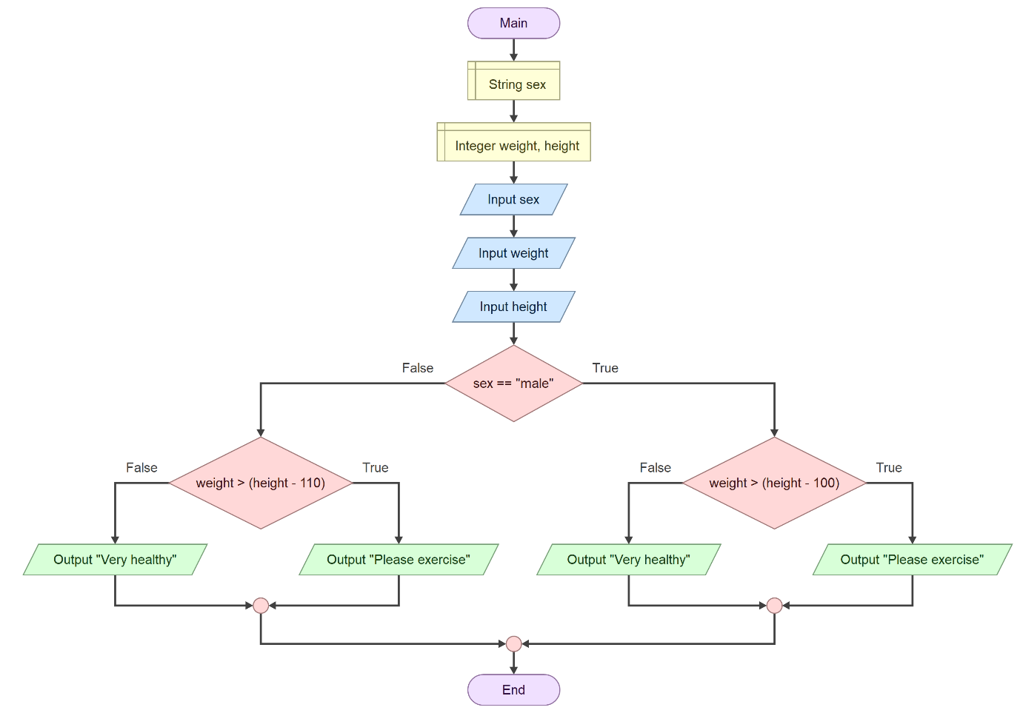

#include <iostream>

#include <sstream>

#include <string>

#include <cstdlib>

#include <cmath>

using namespace std;

// Headers

string toString (double);

int toInt (string);

double toDouble (string);

int main() {

string sex;

int weight, height;

cin >> sex;

cin >> weight;

cin >> height;

if (sex == "male") {

if (weight > height - 100) {

cout << "Please exercise" << endl;

} else {

cout << "Very healthy" << endl;

}

} else {

if (weight > height - 110) {

cout << "Please exercise" << endl;

} else {

cout << "Very healthy" << endl;

}

}

return 0;

}

ข้อที่ 7

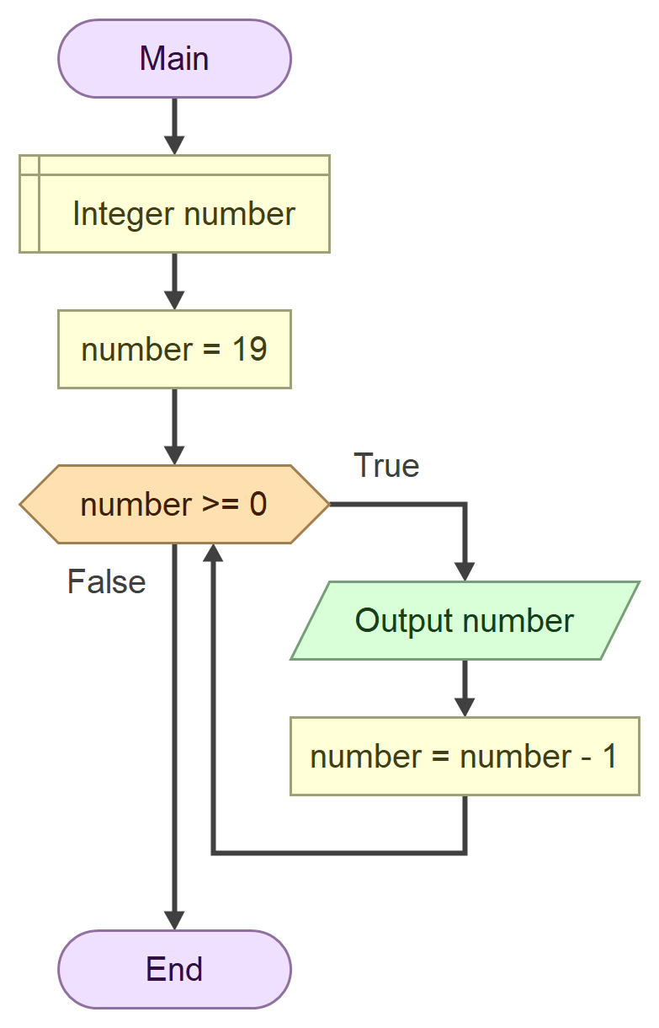

START

INTEGER number

INPUT number = 19

WHILE number >= 0

PRINT number

Number = number – 1

END

ข้อที่ 8

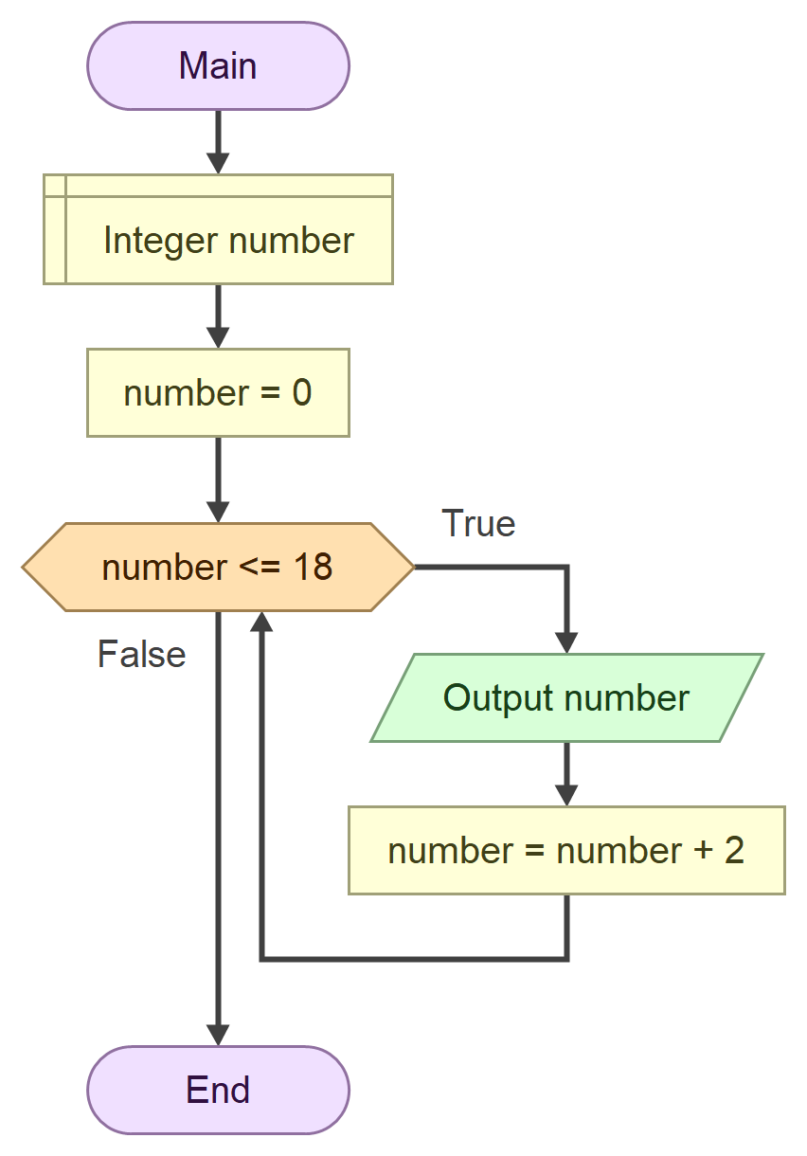

START

INTEGER number

INPUT number = 0

WHILE number <= 18

PRINT number

number = number + 2

END

ข้อที่ 9

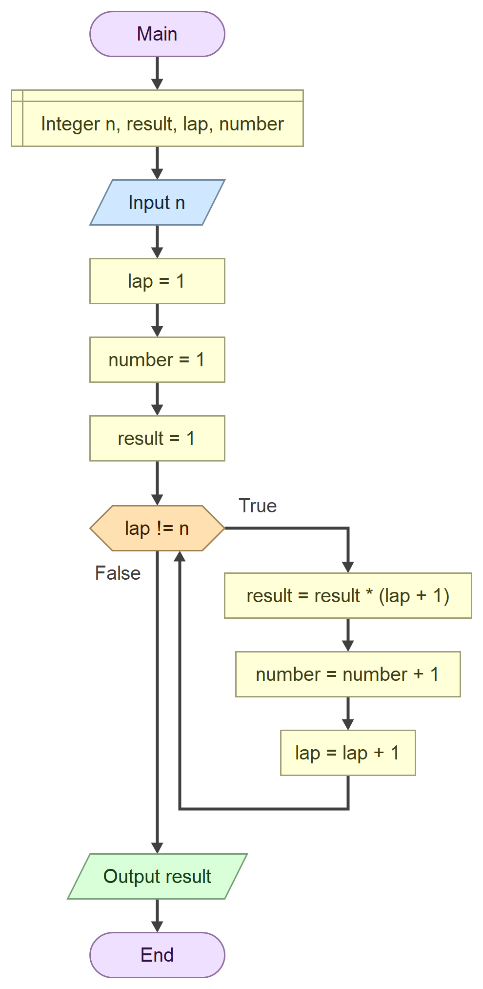

START

INTEGER n, result, lap, number

INPUT n

INTEGER lap = 1

INTEGER number = 1

INTEGER result = 1

WHILE lap != n

result = result * (lap + 1)

number = number + 1

lap = lap + 1

PRINT result

END

ข้อที่ 10

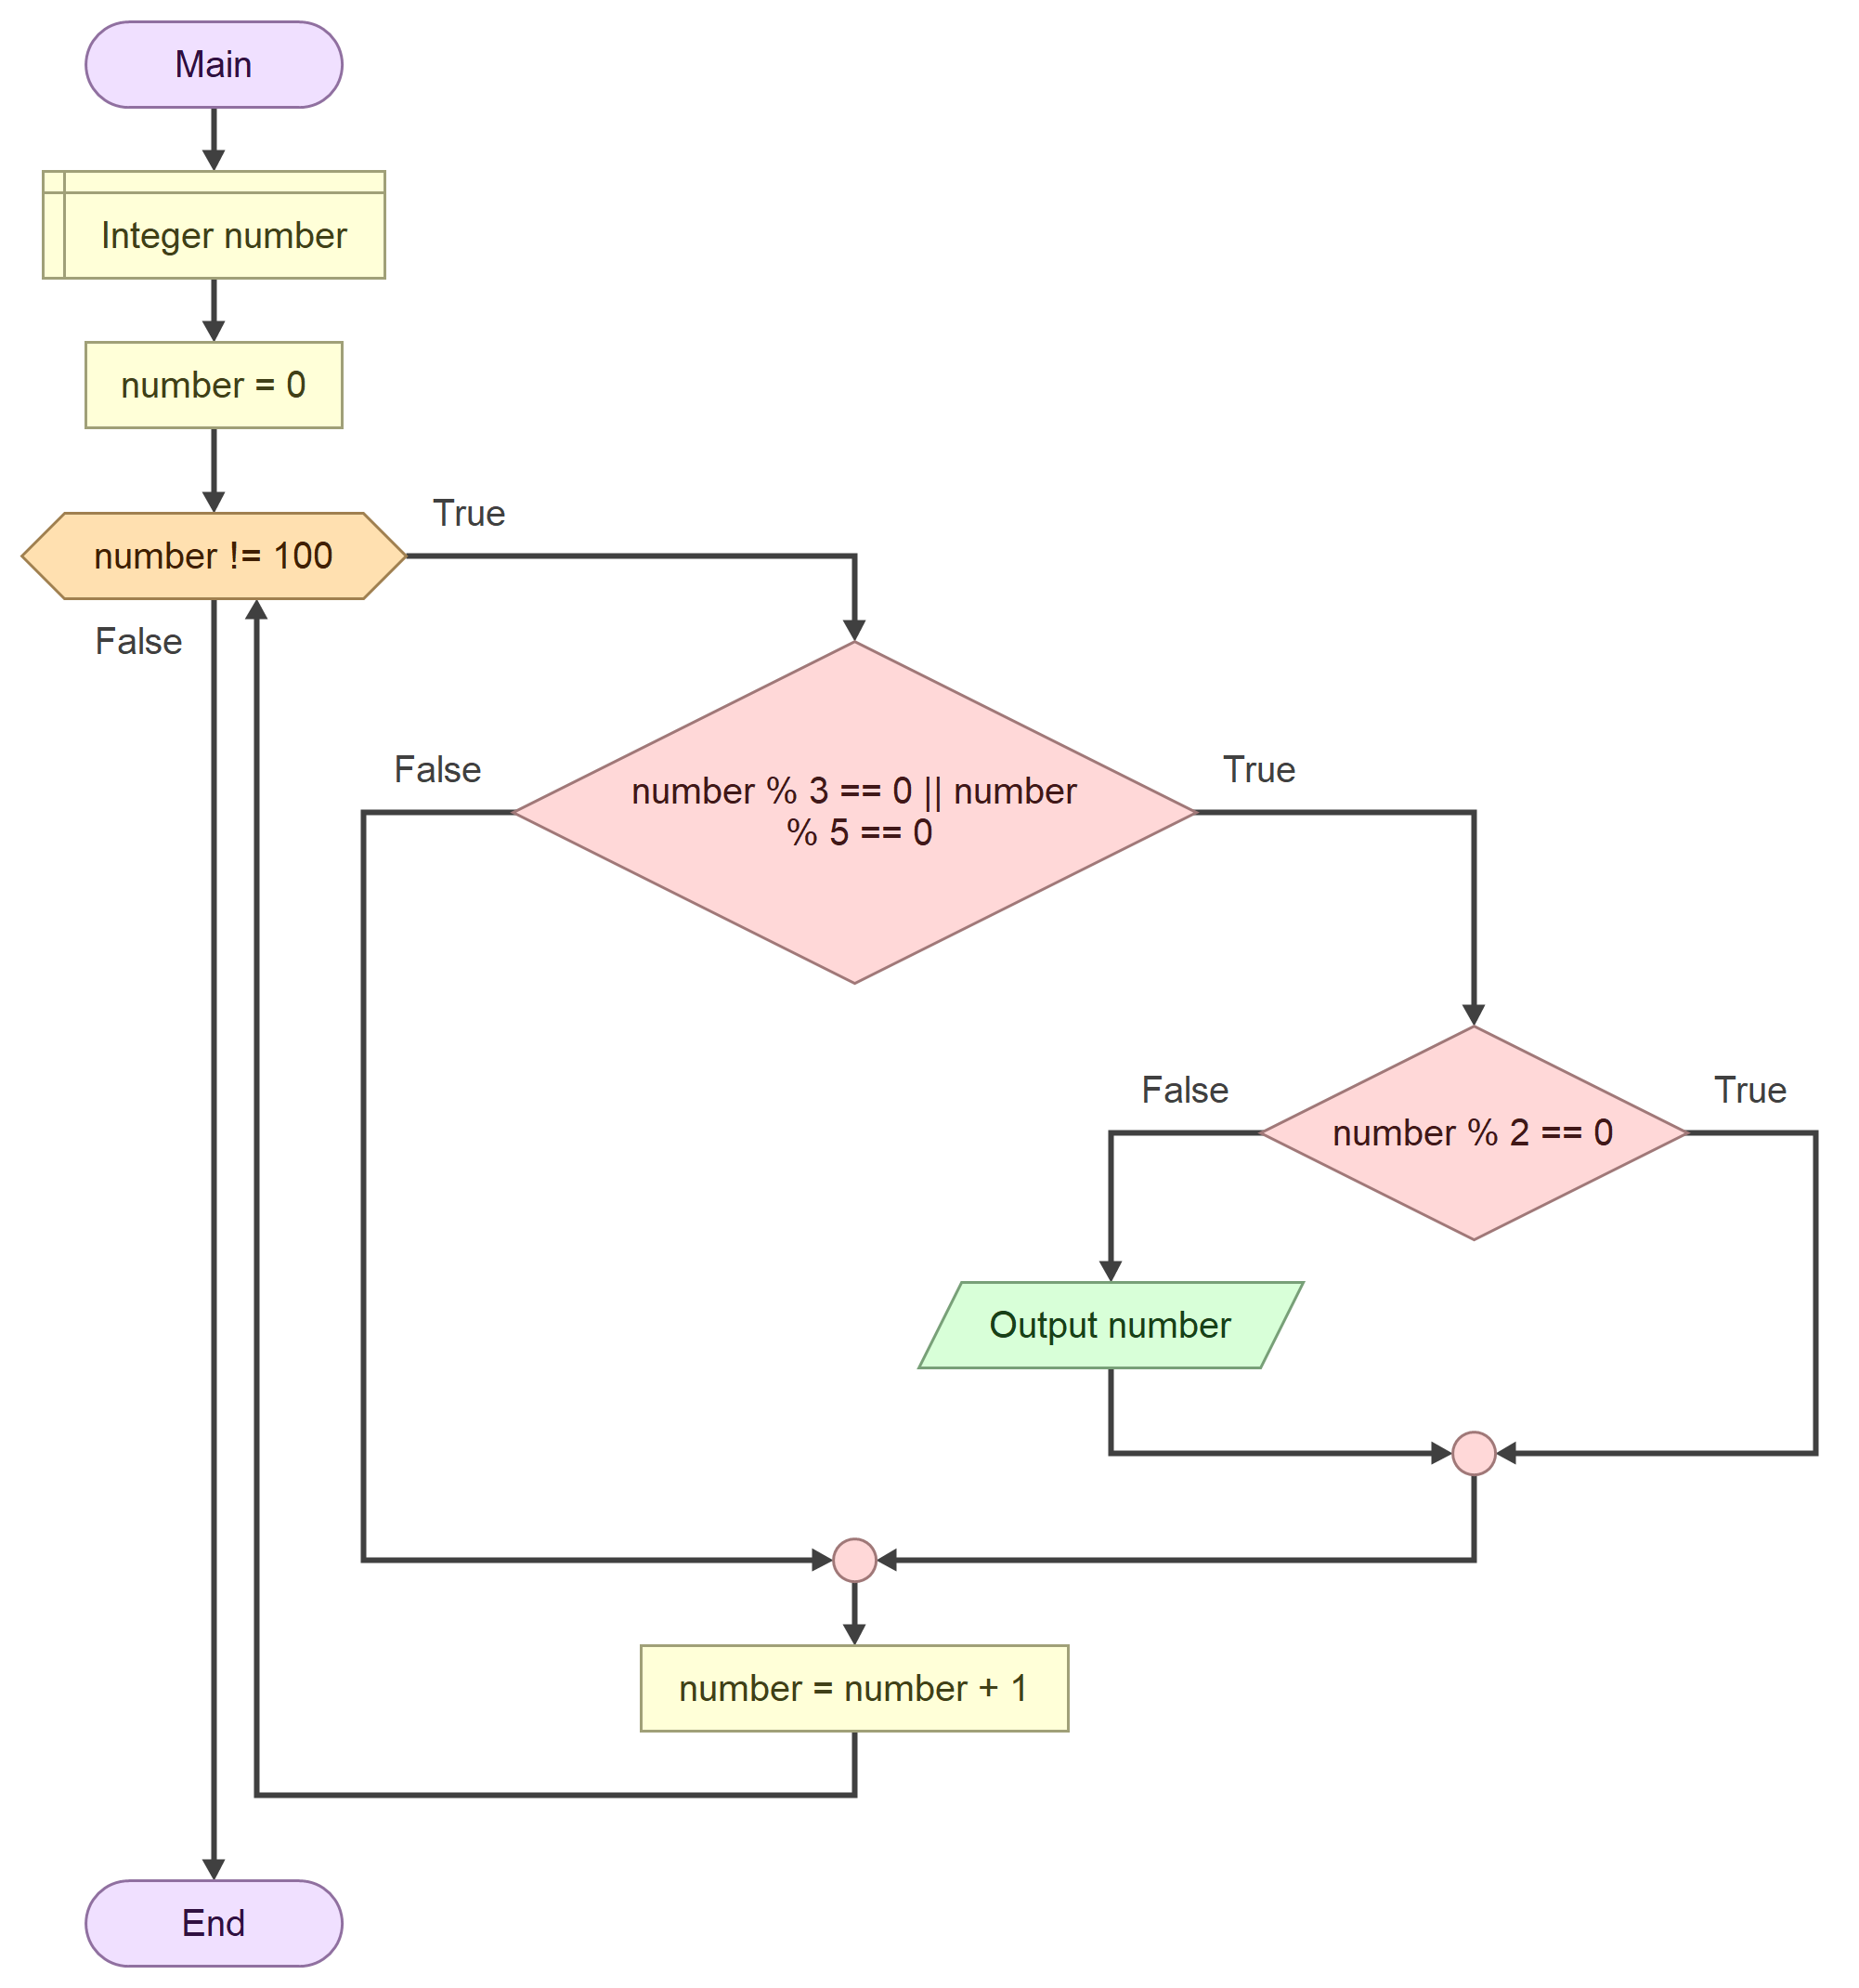

START

INTEGER number

INTEGER number = 0

WHILE number != 100

IF number % 3 == 0 || number % 5 == 0

IF number % 2 == 0

ELSE

PRINT number

END IF

END IF

number = number + 1

END